**1. Bar Chart: Survey Responses by City**

This visualization helps you see how many responses came from each city.

**- Fields:**

- From `dim_cities`: `city_name`

- From `fact_survey_responses`: `response_id` (count)

**- Steps:**

- Select the Bar Chart visualization.

- Drag `city_name` from `dim_cities` into the Axis field.

- Drag `response_id` from `fact_survey_responses` into the Values field.

**- Result:**

A bar chart showing the number of survey responses from each city.

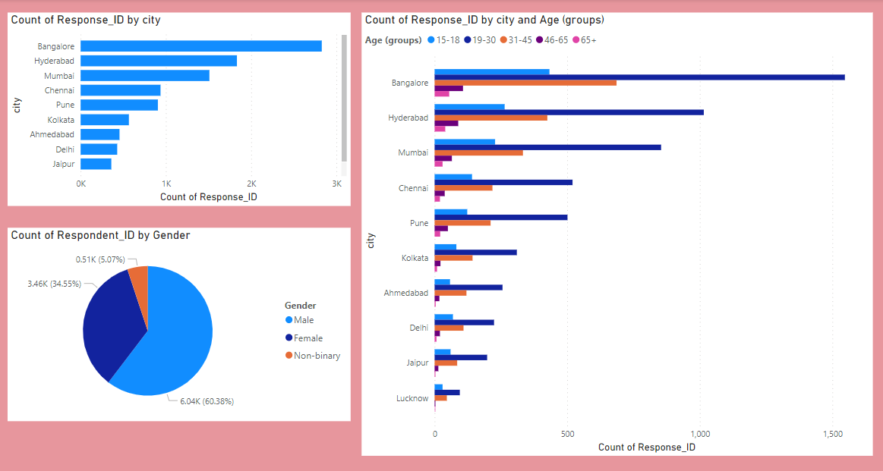

**2. Pie Chart: Respondents by Gender**

This will show the gender distribution of respondents.

**- Fields:**

- From `dim_respondents`: `gender`

- From `dim_respondents`: `respondent_id` (count)

**- Steps:**

- Select the Pie Chart visualization.

- Drag `gender` from `dim_respondents` into the Legend field.

- Drag `respondent_id` into the Values field to count the number of respondents.

**- Result:**

A pie chart displaying the proportion of male and female respondents.



**3. Clustered Column Chart: Responses by Age Group and City**

This helps compare responses by age group across different cities.

**- Fields:**

- From `dim_cities`: `city_name`

- From `dim_respondents`: `age_group`

- From `fact_survey_responses`: `response_id` (count)

**- Steps:**

- Select the Clustered Column Chart visualization.

- Drag `city_name` from `dim_cities` into the Axis field.

- Drag `age_group` from `dim_respondents` into the Legend field.

- Drag `response_id` from `fact_survey_responses` into the Values field.

**- Result:**

A clustered column chart that shows the number of responses per age group in each city.



**4. Stacked Bar Chart: Responses by City and Gender**

This will show how survey responses are distributed by gender within each city.

**- Fields:**

- From `dim_cities`: `city_name`

- From `dim_respondents`: `gender`

- From `fact_survey_responses`: `response_id` (count)

**- Steps:**

- Select the Stacked Bar Chart visualization.

- Drag `city_name` from `dim_cities` into the Axis field.

- Drag `gender` from `dim_respondents` into the Legend field.

- Drag `response_id` from `fact_survey_responses` into the Values field.

**- Result:**

A stacked bar chart showing responses by gender in each city.

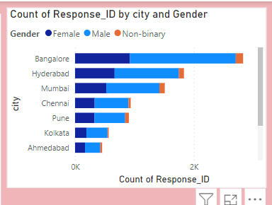

**5. Table: Detailed View of Survey Responses**

Create a table to view detailed information from the survey responses.

**- Fields:**

- From `dim_cities`: `city_name`

- From `dim_respondents`: `age_group`, `gender`

- From `fact_survey_responses`: `response_text`

**- Steps:**

- Select the Table visualization.

- Drag `city_name`, `age_group`, `gender`, and `response_text` into the Values field.

**- Result:**

A table displaying the city, age group, gender, and survey response text for each respondent.

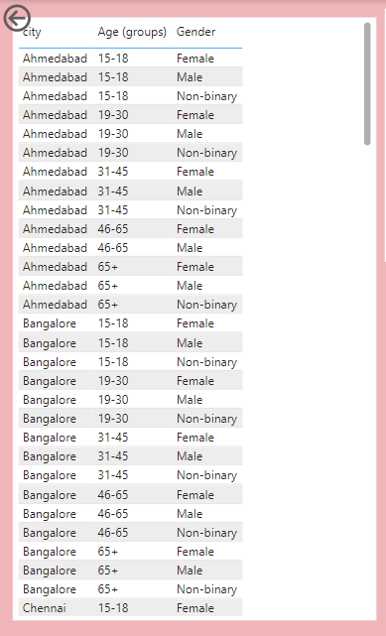

**6. Stacked Area Chart: Responses Over Time by Age Group**

This chart shows how responses have changed over time for different age groups.

**- Fields:**

- From `fact_survey_responses`: `response_date`

- From `dim_respondents`: `age_group`

- From `fact_survey_responses`: `response_id` (count)

**- Steps:**

- Select the Stacked Area Chart visualization.

- Drag `response_date` into the Axis field.

- Drag `age_group` from `dim_respondents` into the Legend field.

- Drag `response_id` into the Values field.

**- Result:**

A stacked area chart showing the number of responses over time broken down by age groups.

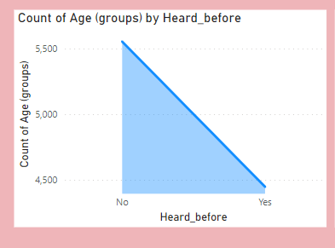

**7. Donut Chart: Percentage of Responses by Age Group**

This is similar to a pie chart but provides a clearer display of data with a hole in the middle.

**- Fields:**

- From `dim_respondents`: `age_group`

- From `fact_survey_responses`: `response_id` (count)

**- Steps:**

- Select the Donut Chart visualization.

- Drag `age_group` into the Legend field.

- Drag `response_id` into the Values field.

**- Result:**

A donut chart showing the percentage of total responses from different age groups.

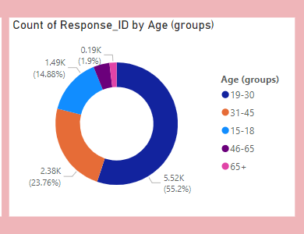

**8. Treemap: Responses by Age Group and Gender**

A treemap shows data in nested rectangles, giving a sense of proportionality.

**- Fields:**

- From `dim_respondents`: `age_group`, `gender`

- From `fact_survey_responses`: `response_id` (count)

**- Steps:**

- Select the Treemap visualization.

- Drag `age_group` into the Group field.

- Drag `gender` into the Details field.

- Drag `response_id` into the Values field.

**- Result:**

A treemap that shows the size of each gender category within each age group, based on the number of responses.

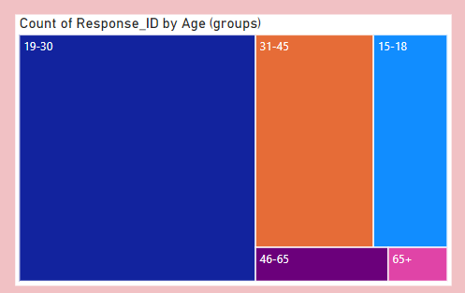

**9. Waterfall Chart: Survey Completion Progress**

If you want to show the progression of responses, for example, the number of surveys completed over different periods (daily or weekly), a waterfall chart is useful.

**- Fields:**

- From `fact_survey_responses`: `consume_time`, `response_id` (count)

**- Steps:**

- Select the Waterfall Chart visualization.

- Drag `consume_time` into the Category field.

- Drag `response_id` into the Values field.

**- Result:**

A waterfall chart showing how the number of responses has accumulated over time.

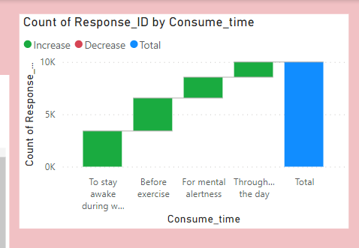

**10. Key Influencers: Factors Driving Satisfaction**

If you have a satisfaction score or similar metric, you can use this visualization to see what factors (like age, gender, or city) influence satisfaction.

**- Fields:**

- From `fact_survey_responses`: `consumer_frequency `

- From `dim_respondents`: `age`, `gender`

- From `dim_cities`: `city_name`

**- Steps:**

- Select the Key Influencers visualization.

- Drag `consumer_frequency` into the Analyzed Field.

- Drag `age`, `gender`, and `city_name` into the Explain By field.

**- Result:**

A key influencers chart showing the factors that have the most influence on the satisfaction score.

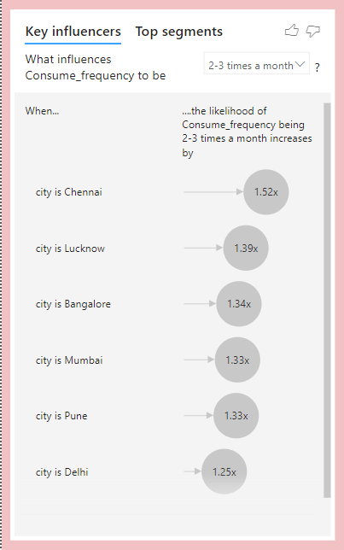

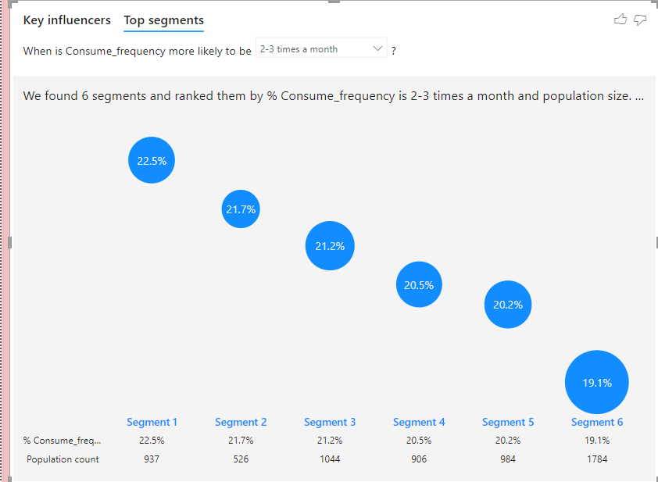

**11. Funnel Chart: Survey Completion Stages**

If your survey had multiple stages or questions, you can use a funnel chart to show how respondents moved through each stage.

**- Fields:**

- price range , brand preception

**- Steps:**

- Select the Funnel Chart visualization.

- Drag the completion data for each survey stage into the Values field.

**- Result:**

A funnel chart showing how many respondents completed each stage of the survey.

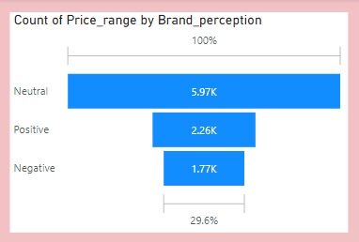

**12. Area chart : Interactive Filtering by Age, City, or Gender**

A slicer is not a visualization itself but a way to add interactive filters to your report.

**- Fields:**

- `response_id `: `age_group`, `city name`

**- Steps:**

- Select the Area chart visualization.

- drag ‘city’ into the axis field

- drag ‘count of age’ into the axis field

- drag the ‘count of response_id’ into the secondary axis

**- Result:**

An interactive slicer that allows users to filter your visuals by city, age group, or gender.

